A balancing robot kit is now avaliable via Kickstarter:[http://www.kickstarter.com/projects/tkjelectronics/balanduino-balancing-robot-kit](http://www.kickstarter.com/projects/tkjelectronics/balanduino-balancing-robot-kit" \t "_blank). Check out the blog post as well: [http://blog.tkjelectronics.dk/2013/03/balanduino-balancing-robot-kit-kickstarter/](http://blog.tkjelectronics.dk/2013/03/balanduino-balancing-robot-kit-kickstarter/" \t "_blank).

Hello everybody  
I have for a long time wanted to build a remote controllable balancing robot aka Segway – that’s was actually the main reason why I created the PS3 Bluetooth Library both for [Arduino](http://blog.tkjelectronics.dk/2012/01/ps3-controller-bt-library-for-arduino/" \t "_blank) and the [FEZ Devices](http://blog.tkjelectronics.dk/2012/01/demonstration-of-the-ps3-controllers-in-action/" \t "_blank). It has been a long time since the [sneak peak](http://blog.tkjelectronics.dk/2011/12/sneak-peak-segway-guide-code/" \t "_blank) and the performance has been improved a lot since then. The original one had a [FEZ Rhino](http://www.ghielectronics.com/catalog/product/132" \t "_blank) as the main processor, but I discovered that it was not fast enough to read the encoders, as it is not running embedded code. Also I was already using more than 10ms per loop, which I used as a fixed time loop, so I decided to step up a notch and go for a much more powerful device: the [mbed microcontroller](http://mbed.org/handbook/mbed-NXP-LPC1768" \t "_blank), which is an ARM Cortex-M3 running 96MHz.

It might have been possible with just a normal Arduino **(NB: I have now ported the code to Arduino, see [update](http://blog.tkjelectronics.dk/2012/03/the-balancing-robot/" \l "update) for the code)**, but I didn’t want the speed of the processor to be an issue, so I decided to go for the mbed. The robot also features an [Arduino Duemilanove](http://arduino.cc/en/Main/arduinoBoardDuemilanove" \t "_blank) with a [USB Host Shield](http://shop.tkjelectronics.dk/product_info.php?products_id=43" \t "_blank) on top running a [sketch](https://github.com/TKJElectronics/BalancingRobotRemote" \t "_blank) based on my [PS3 Bluetooth Library](https://github.com/TKJElectronics/USB_Host_Shield_2.0" \t "_blank). The mbed board actually has USB Host functionality, but I decided not to port the PS3 Bluetooth Library as my original thought were to use an [Arduino Due](http://arduino.cc/blog/2011/09/17/arduino-launches-new-products-in-maker-faire/" \t "_blank), but as you might know it hasn’t been released yet, despite the Arduino team announced, that it would be released by the end of 2011. But as soon as it is released I think I will port the code to it instead.

**Video Demonstration**  
Here is a short video demonstration of the robot and me explaining some of the concepts of the design and how it works:  
  
  
**The Hardware**  
Here are some pictures of the robot:

[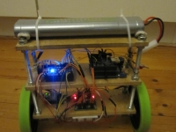](http://blog.tkjelectronics.dk/wp-content/gallery/balancingrobot/img_2779.jpg)

[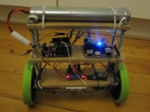](http://blog.tkjelectronics.dk/wp-content/gallery/balancingrobot/img_2780.jpg)

[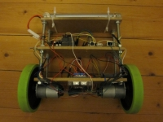](http://blog.tkjelectronics.dk/wp-content/gallery/balancingrobot/img_2782.jpg)

[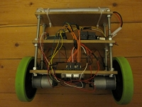](http://blog.tkjelectronics.dk/wp-content/gallery/balancingrobot/img_2783.jpg)

[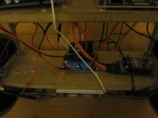](http://blog.tkjelectronics.dk/wp-content/gallery/balancingrobot/img_2786.jpg)

[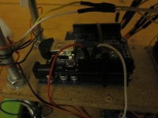](http://blog.tkjelectronics.dk/wp-content/gallery/balancingrobot/img_2787.jpg)

[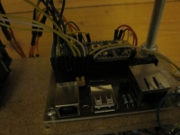](http://blog.tkjelectronics.dk/wp-content/gallery/balancingrobot/img_2788.jpg)

[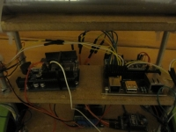](http://blog.tkjelectronics.dk/wp-content/gallery/balancingrobot/img_2792.jpg)

[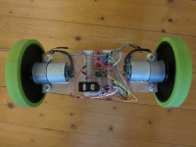](http://blog.tkjelectronics.dk/wp-content/gallery/balancingrobot/img_2794.jpg)

Here is a list of all the hardware I used:

* [Motors with build in encoders](http://www.pololu.com/catalog/product/1443" \t "_blank)
* [Motor Brackets](http://www.pololu.com/catalog/product/1084)
* [Motor driver](http://www.pololu.com/catalog/product/708)
* [BaneBots Wheels](http://www.robotshop.com/eu/banebots-08in-5in-hex-wheels-4.html" \t "_blank) (These wheels are no longer available from the seller, but you can use these[wheels](http://www.robotshop.com/eu/ban-135-green-wheel.html" \t "_blank) and these [hubs](http://www.robotshop.com/eu/banebots-hex-hubs-s80.html" \t "_blank) instead)
* [Hubs](http://www.robotshop.com/eu/hex-hub-s40-6mm-2wide.html" \t "_blank)
* [IMU](http://www.sparkfun.com/products/10010)
* [mbed microcontroller](http://mbed.org/handbook/mbed-NXP-LPC1768)
* [mbed breakout board](http://shop.tkjelectronics.dk/product_info.php?cPath=22&products_id=30)
* [Arduino Duemilanove](http://arduino.cc/en/Main/arduinoBoardDuemilanove" \t "_blank) for PS3 bluetooth communication
* [USB Host Shield](http://shop.tkjelectronics.dk/product_info.php?products_id=43" \t "_blank)
* [Bluetooth dongle](https://github.com/TKJElectronics/USB_Host_Shield_2.0/wiki" \l "wiki-Hardware" \t "_blank) – it has to support bluetooth version 2.0+EDR
* [PS3 Controller](http://us.playstation.com/ps3/accessories/dualshock-3-wireless-controller-ps3.html" \t "_blank)
* [12V 3800mAh NiMH Batteries](http://www.ebay.com/itm/1x-Tamiya-Battery-Pack-12V-3800mAh-NiMH-808-Charger-EU-/250985344195?pt=LH_DefaultDomain_0&hash=item3a6fe46cc3" \l "ht_2174wt_1072" \t "_blank) – I got two of them
* [Female Tamiya connector](http://www.ebay.com/itm/5-pairs-Male-Female-white-Standard-Tamiya-connector-plug-RC-Airsoft-battery-pack-/160748733394?pt=UK_ToysGames_RadioControlled_JN&hash=item256d5f03d2" \t "_blank)
* [Two XBee modules](http://www.watterott.com/en/Digi-XBee-1mW-Chip-Antenna" \t "_blank) for wireless debugging and setting the PID constants wirelessly. Alternativly you could use an inexpensive [Bluetooth Serial module](http://www.ebay.com/itm/250990071548?ssPageName=STRK:MEWNX:IT&_trksid=p3984.m1439.l2649#ht_1841wt_1141)
* [Two XBee adapter kits](http://www.watterott.com/de/XBee-Adapter-kit-v11)

I also used:

* [A lot jumper wires](http://shop.tkjelectronics.dk/product_info.php?cPath=24&products_id=34)
* [A voltage regulator (7805)](http://search.digikey.com/us/en/products/KA7805ETU/KA7805ETU-ND/965381)
* [A small breadboard](http://shop.tkjelectronics.dk/product_info.php?cPath=24&products_id=33)

The robot itself is made of three pieces of 215x75x7.5mm [MDF](http://en.wikipedia.org/wiki/Medium-density_fibreboard) wood and four threaded rods. The distance between the plates is 7cm at the bottom and 7.5 at the top. In total the robot is 27cm high including the battery.  
See the [3D model](https://github.com/TKJElectronics/BalancingRobot/tree/master/3D%20Model" \t "_blank) for more information.

**3D Model**  
I have created a 3D model in [Autodesk Inventor](http://usa.autodesk.com/autodesk-inventor/" \t "_blank) with true dimensions, this will hopefully inspire other people for there robot design. All files can be found at [github](https://github.com/TKJElectronics/BalancingRobot/tree/master/3D%20Model" \t "_blank).  
The 3D model can also be viewed at the following site: [http://grabcad.com/library/balancing-robot](http://grabcad.com/library/balancing-robot" \t "_blank).

Check out these rendered images of the robot:

[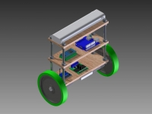](http://blog.tkjelectronics.dk/wp-content/gallery/balancingrobot3d/front-top-left.jpg)

[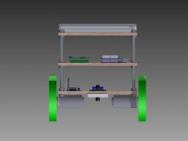](http://blog.tkjelectronics.dk/wp-content/gallery/balancingrobot3d/front.jpg)

[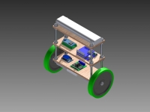](http://blog.tkjelectronics.dk/wp-content/gallery/balancingrobot3d/front-top-right.jpg)

[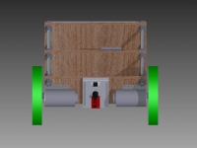](http://blog.tkjelectronics.dk/wp-content/gallery/balancingrobot3d/front-bottom.jpg)

[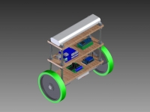](http://blog.tkjelectronics.dk/wp-content/gallery/balancingrobot3d/back-top-left.jpg)

[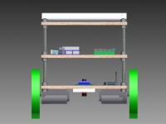](http://blog.tkjelectronics.dk/wp-content/gallery/balancingrobot3d/back.jpg)

[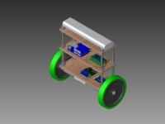](http://blog.tkjelectronics.dk/wp-content/gallery/balancingrobot3d/back-top-right.jpg)

[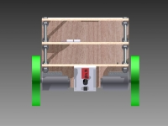](http://blog.tkjelectronics.dk/wp-content/gallery/balancingrobot3d/back-bottom.jpg)

**The Code**  
All the code and 3D model can be found at [our github](https://github.com/tkjelectronics). Here is a list of hyperlinks for all the repositories:

* [mbed code](https://github.com/TKJElectronics/BalancingRobot)
* [Arduino Sketch](https://github.com/TKJElectronics/BalancingRobotRemote)
* [PS3 Bluetooth Library for Arduino](https://github.com/TKJElectronics/USB_Host_Shield_2.0)
* [Processing application](https://github.com/TKJElectronics/BalancingRobot/tree/master/PIDController)

Also check out the [wiki](https://github.com/TKJElectronics/BalancingRobot/wiki).

**Update**  
I have now ported the code to Arduino. The code can be found at github:[https://github.com/TKJElectronics/BalancingRobotArduino](https://github.com/TKJElectronics/BalancingRobotArduino" \t "_blank).

**Improvements**  
I have thought about how I could improve the performance of the robot. First of all I could try to use an accelerometer with a smaller resolution, as the one I got is a ±3g and ±1.5g would be sufficient for my needs. Also my gyro got a resolution of ±300 deg/s and I have seen people use gyro with a resolution as low as ±50 deg/s.

Another aspect would to use belts to minimize backlash, instead of connecting the wheels directly to the motors – a bit like this [one](http://www.youtube.com/watch?v=Kd2kJxBkPmk).

Also I don’t compensate for the battery level in the code – so it behaves differently depending on the battery level.

**Conclusion**  
Overall I am really happy about the end result – it balances pretty well and the remote control works perfect!

It has been a really good learning experience for me and a really fun project to do, but also very time-consuming – I have spend many nights tweaking the PID values and adjusting tiny bits of the code before I accomplished the end result.

The next step would to build a full size one, but I don’t know if I will do it the near future – but hopefully some day 

That’s all for now. Hope you like my robot. Feel free to post a comment below and I will answer as quickly as possible.